
Lab Report No 1

Setting up Environment and getting started with
Python

Digital Signal Processing

Submitted By:

[
Huzaifa Shahbaz
]

[21
-
CE
-
009
]

Submitted to:

Engr. Hareem Khan

Dated:

24
th
Feb,2024

Department of Computer Engineering,

HITEC University, Taxila

Lab Task No A:
Brief description (3-5 lines)
Install Anaconda Spyder and mentioned all steps in your lab report.
The explanation
1.Download the Anaconda installer.
2.Go to your Downloads folder and double-click the installer to launch. To prevent permission errors, do not launch the installer from the Favourites folder.
3.Click Next.
4.Read the licensing terms and click I Agree.
5.It is recommended that you install for Just Me, which will install Anaconda Distribution to just the
current user account. Only select an install for All Users if you need to install for all users’ accounts on the computer (which requires Windows Administrator privileges).
6.Click Next.
7.Select a destination folder to install Anaconda and click Next. Install Anaconda to a directory path that does not contain spaces or Unicode characters.
8.Choose whether to add Anaconda to your PATH environment variable or register Anaconda as your default
Python. We don’t recommend adding Anaconda to your PATH environment
variable, since this can interfere with
other software. Unless you plan on installing and running multiple versions of
Anaconda or multiple versions of
Python, accept the default and leave this box checked. Instead, use Anaconda software by opening Anaconda
Navigator or the Anaconda Prompt from the Start Menu.
9.Click Install. If you want to watch the packages Anaconda is installing, click Show Details.
10.Click Next.
11.After a successful installation you will see the “Thanks for installing Anaconda” dialog box.
12.Click the Finish button.
Lab Task No B (1(A)):
Brief description (3-5 lines)
Create a list and perform the following methods
- insert()
- remove()
- append()
- len()
- pop()
- clear()
The code
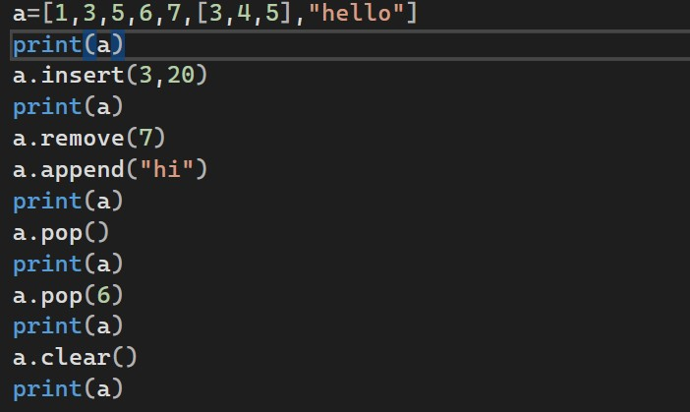
The results (Screenshot)
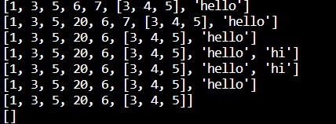
Lab Task No B(1(B)):
Brief description (3-5 lines)
Create a dictionary and apply the following methods
- Print the dictionary items
- access items
- use get()
4)change values
5) use len()
The code
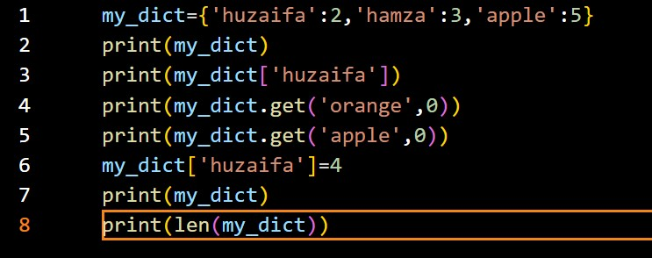
The results (Screenshot)
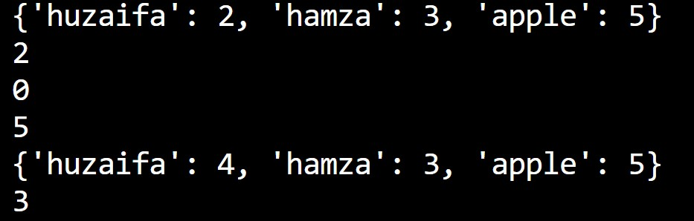

Lab Task No B(1(C)):

Solution:
Brief description (3-5 lines)

Create a tuple and perform the following methods
- Add items
- len()
- check for item in tuple
4)Access items
The code
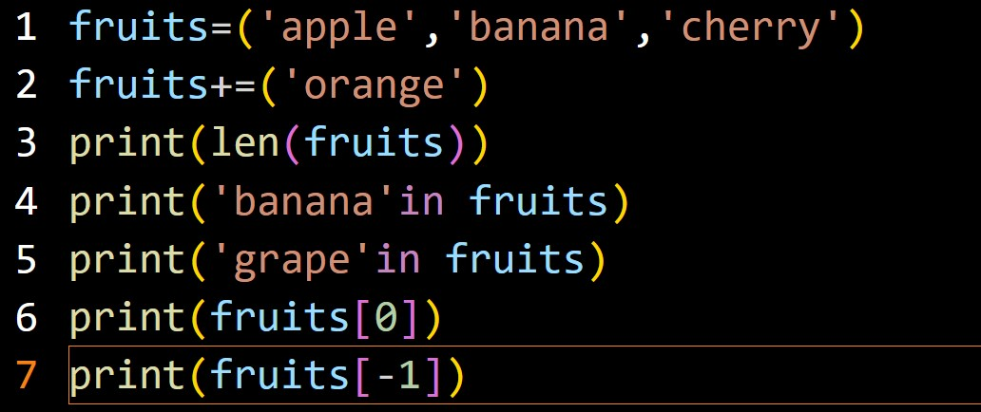
The results (Screenshot)
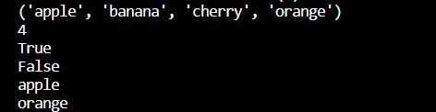

Lab Task No B(2(A)):

Solution:
Brief description (3-5 lines)
Write a python program to add two numbers.
The code
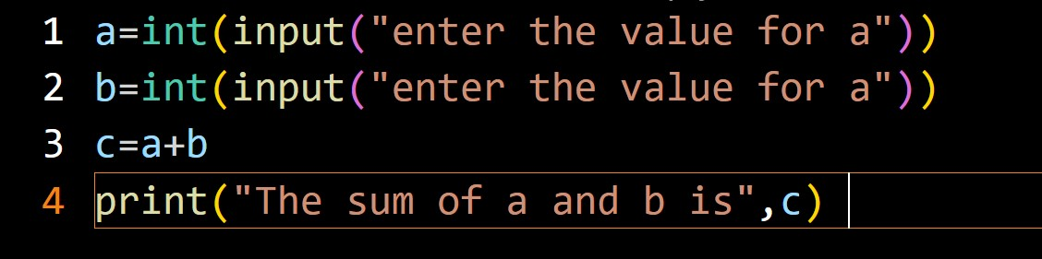
The results (Screenshot)
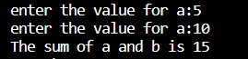

Lab Task No B(2(B)):

Solution:
Brief description (3-5 lines)
Write a python program to print a number is positive/negative using if-else.
The code
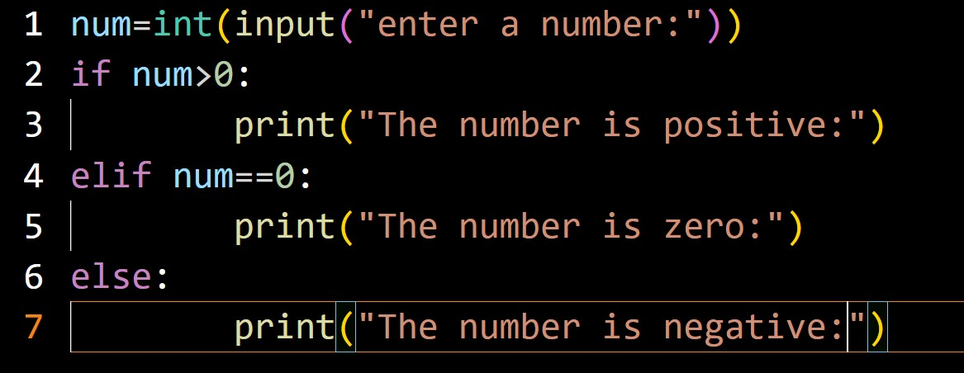
The results (Screenshot)
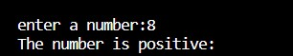

Lab Task No B(2(C)):

Solution:
Brief description (3-5 lines)
Write a python program to find largest number among three numbers.
The code
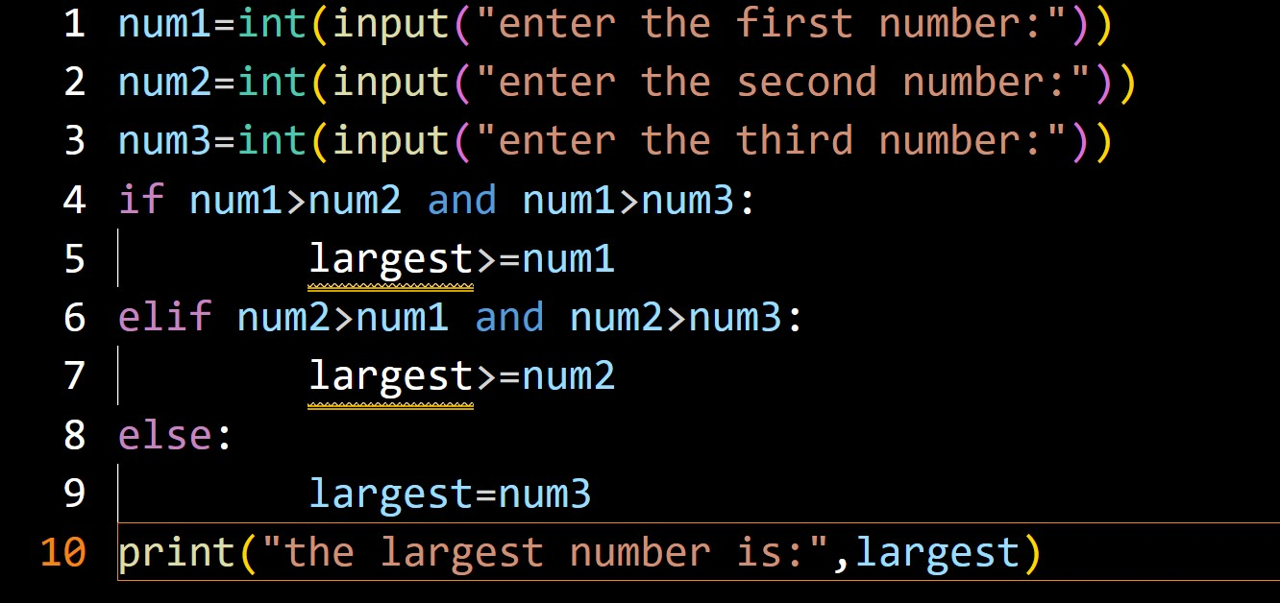
The results (Screenshot)
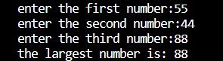

Lab Task No B(2(D)):

Solution:
Brief description (3-5 lines)
Write a python Program to read a number and display corresponding day using if_elif_else?
The code
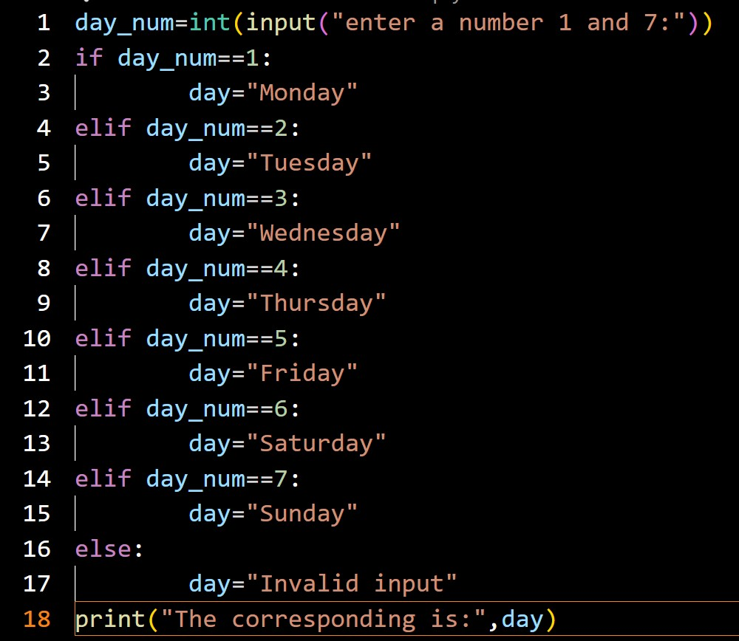
The results (Screenshot)
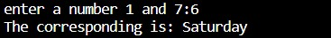

Lab Task No B(3(A)):

Solution:
Brief description (3-5 lines)
Write a programto create a menu with the following options
- TO PERFORM ADDITITON
- TO PERFORM SUBTRACTION
- TO PERFORM MULTIPICATION
- TO PERFORM DIVISION

Accepts users input and perform the operation accordingly. Use functions with arguments.
The code
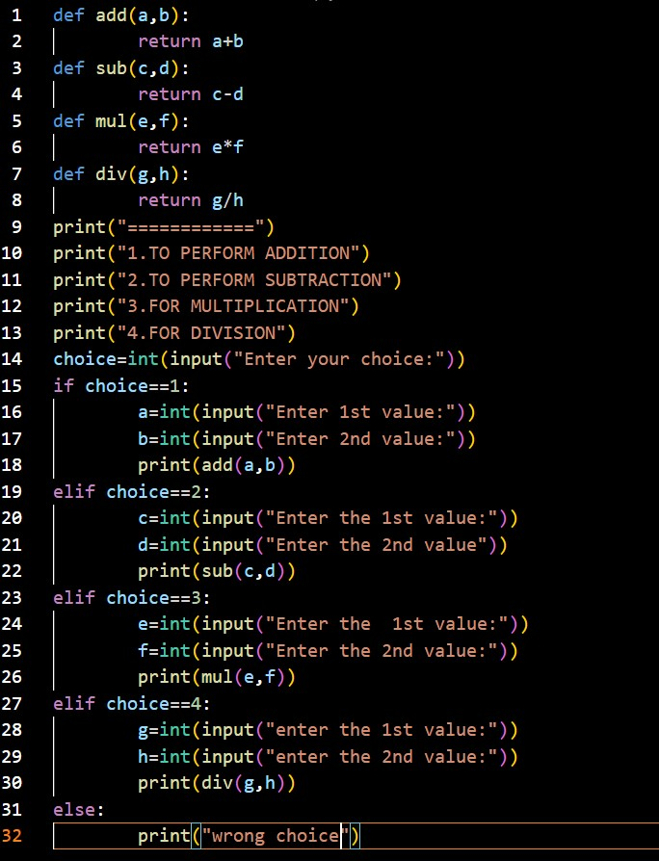
The results (Screenshot)
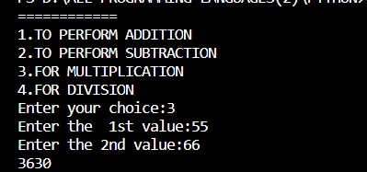

Lab Task No B(3(B)):

Solution:
Brief description (3-5 lines)
Write a python program to check whether the given string is palindrome or not.
The code
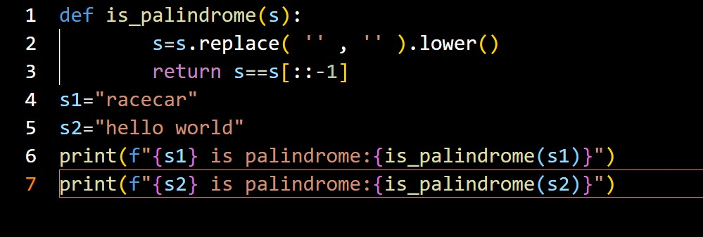
The results (Screenshot)
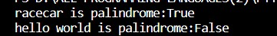

Lab Task No B(3(C)):

Solution:
Brief description (3-5 lines)
Write a python program to find factorial of a given number using functions.
The code

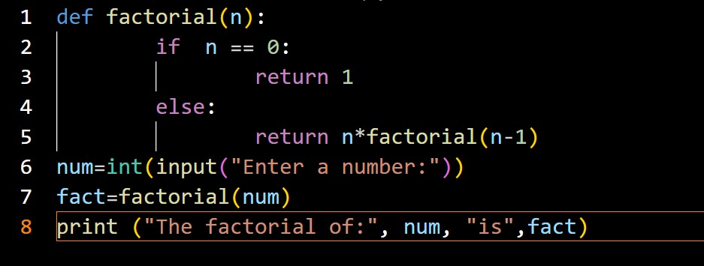
The results (Screenshot)
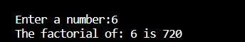

Lab Task No B(3(D)):

Solution:
Brief description (3-5 lines)
Write a Python function that takes two lists and returns True if they are equal otherwise false.
The code
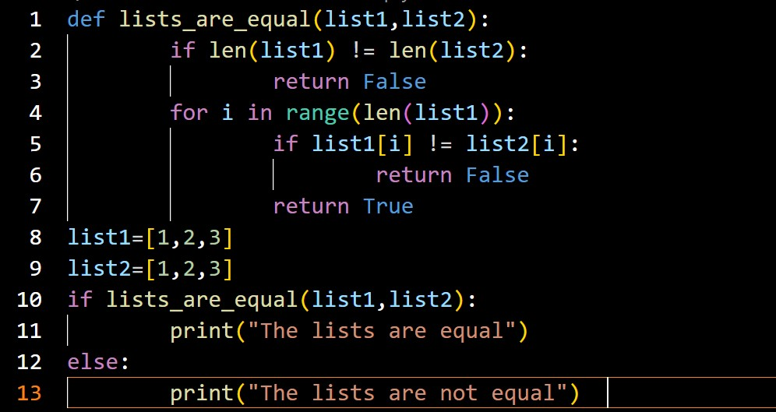
The results (Screenshot)

Lab Task No B(4(A)):

Solution:
Brief description (3-5 lines)
Write a program to double a given number and add two numbers using lambda()?
The code
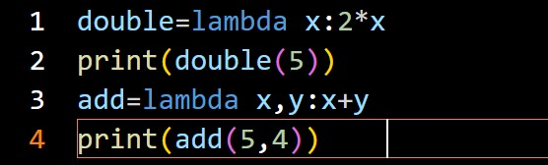
The results (Screenshot)
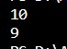

Lab Task No B(4(B)):

Solution:
Brief description (3-5 lines)
Write a program for filter() to filter only even numbers from a given list.
The code
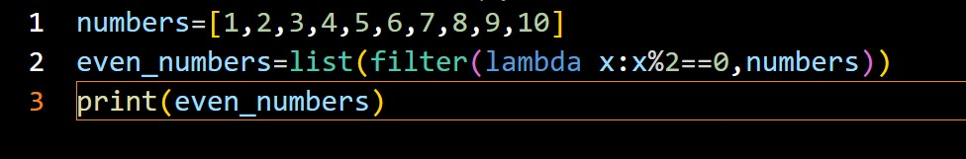
The results (Screenshot)
Lab Task No B(4(C)):

Solution:
Brief description (3-5 lines)
Write a program for map() function to double all the items in the list?
The code
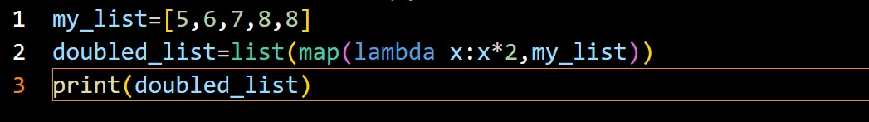
The results (Screenshot)

Lab Task No B(4(D)):

Solution:
Brief description (3-5 lines)
Write a program to find sum of the numbers for the elements of the list by using reduce()?
The code
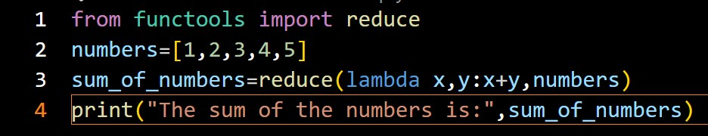
The results (Screenshot)

Lab Task No B(5(A)):

Solution:
Brief description (3-5 lines)
Demonstrate a python code to implement abnormal termination?
The code
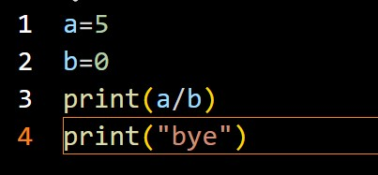
The results (Screenshot)
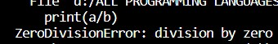

Lab Task No B(5(B)):

Solution:
Brief description (3-5 lines)
Demonstrate a python code to print try, except and finally block statements.
The code
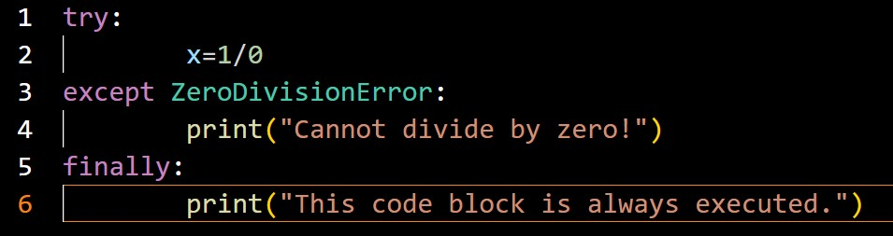
The results (Screenshot)
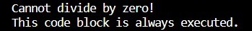

Lab Task No B(5(C)):

Solution:
Brief description (3-5 lines)
Write a python program to open and write “hello world” into a file?
The code
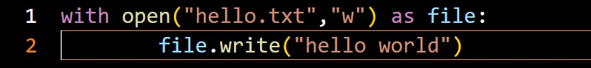
The results (Screenshot)
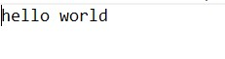

Lab Task No B(5(D)):

Solution:
Brief description (3-5 lines)
Write a python program to write the content “hi python programming” for the existing file.
The code
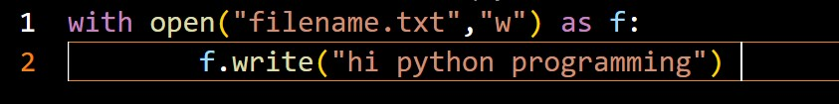
The results (Screenshot)
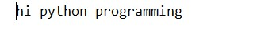

Lab Task No B(6(A)):

Solution:
Brief description (3-5 lines)
Write a python program to get python version.
The code
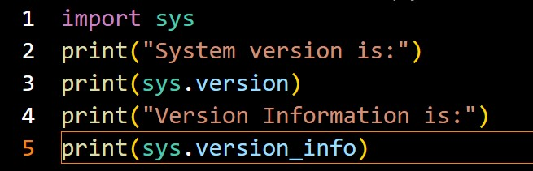
The results (Screenshot)
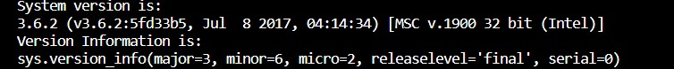

Lab Task No B(6(B)):

Solution:
Brief description (3-5 lines)
Write a python program to open a file and check what are the access permissions acquire by that file using os module?
The code
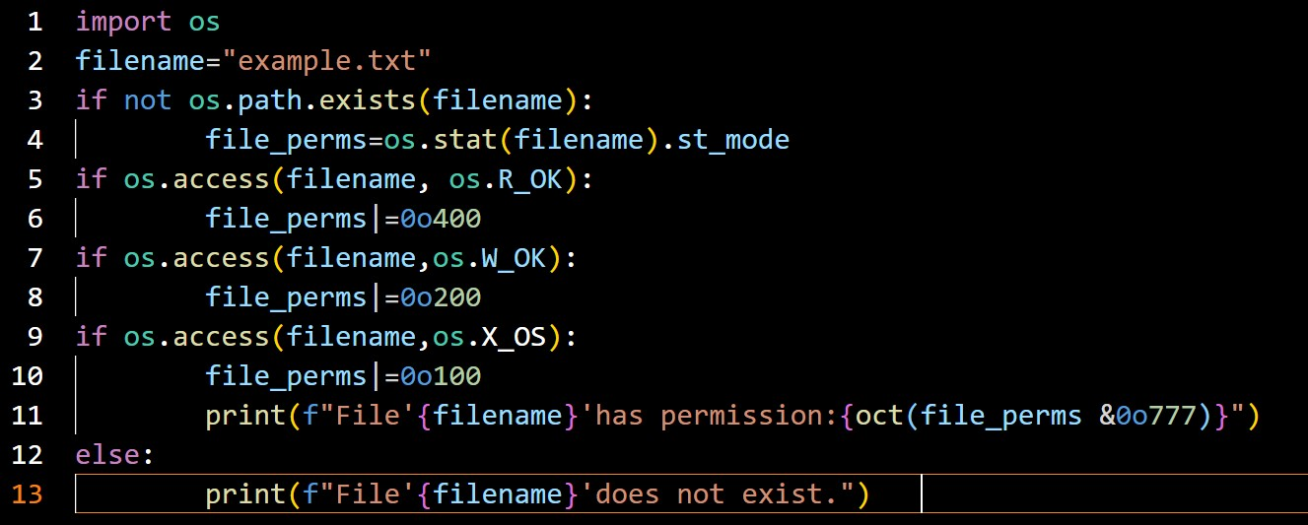
The results (Screenshot)
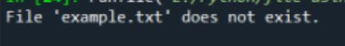
Lab Task No B(6(C)):

Solution:
Brief description (3-5 lines)
Write a python program to display a particular month of a year using calendar module.
The code
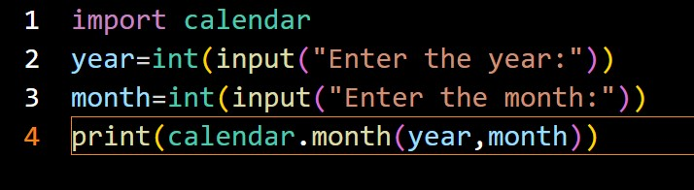
The results (Screenshot)
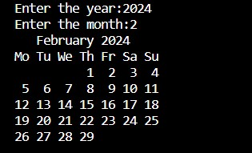

Lab Task No B(6(D)):

Solution:
Brief description (3-5 lines)
Write a python program to print all the months of given year.
The code
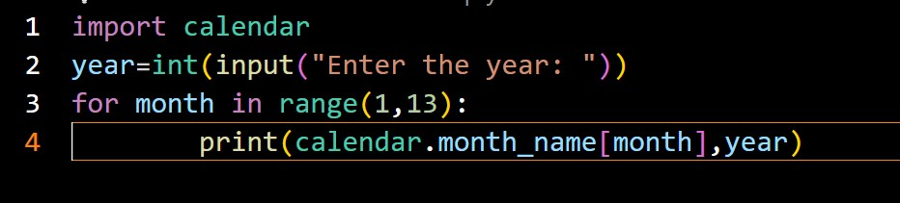
The results (Screenshot)
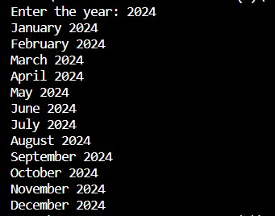

Lab Task No B(7(A)):

Solution:
Brief description (3-5 lines)
Write a python program to print date, time for today and now.
The code
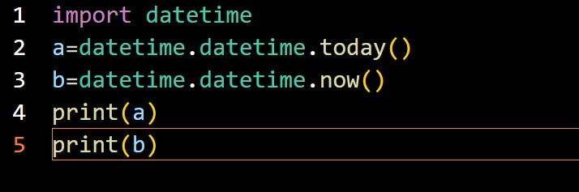
The results (Screenshot)
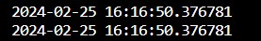

Lab Task No B(7(B)):

Solution:
Brief description (3-5 lines)
Write a python program to add some days to your present date and print the date added.
The code
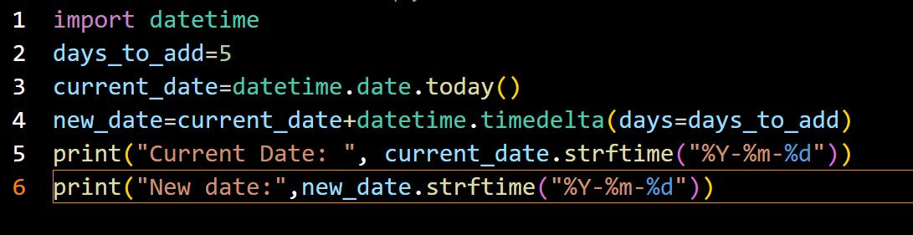
The results (Screenshot)
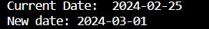

Lab Task No B(7(C)):

Solution:
Brief description (3-5 lines)
Write a python program to print date, time using date and time functions
The code
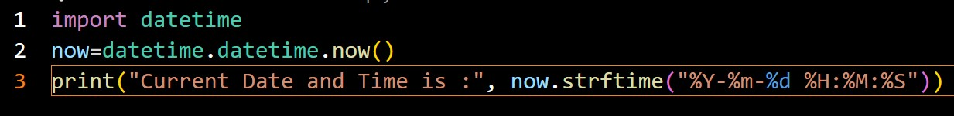
The results (Screenshot)

Lab Task No B(7(D)):

Solution:
Brief description (3-5 lines)
Write a python program which accepts the radius of a circle from user and computes the area (use math module).
The code
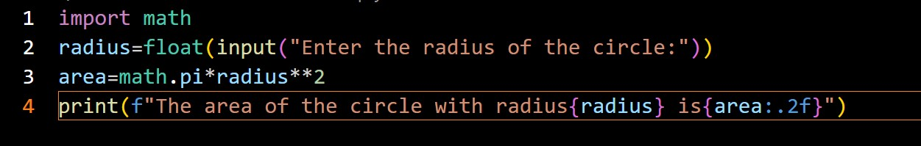
The results (Screenshot)

Lab Task No B(8(A)):

Solution:
Brief description (3-5 lines)
Write a python program to create a package (college),sub-package
(alldept),modules(it,cse) and create admin and cabin function to module?
The code
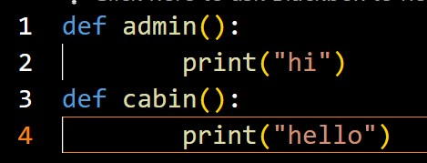
The results (Screenshot)
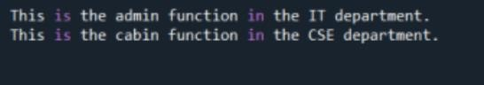

Lab Task No B(8(B)):

Solution:
Brief description (3-5 lines)
Write a python program to create a package (Engg), sub-package( years),modules (sem) and create staff and student function to module?
The code
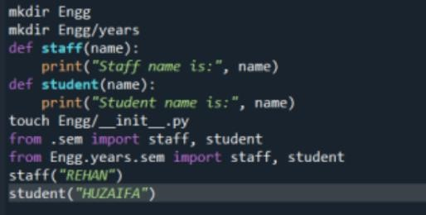
The results (Screenshot)
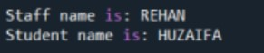

Lab Task No B(9(A)):

Solution:
Brief description (3-5 lines)
Write a python Program to display welcome to MRCET by using classes and objects.
The code
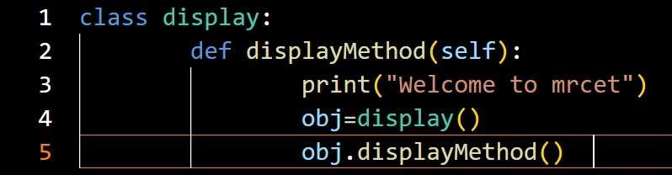
The results (Screenshot)
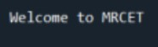

Lab Task No B(9(B)):

Solution:
Brief description (3-5 lines)
Write a python Program to call data member and function using classes and objects.
The code
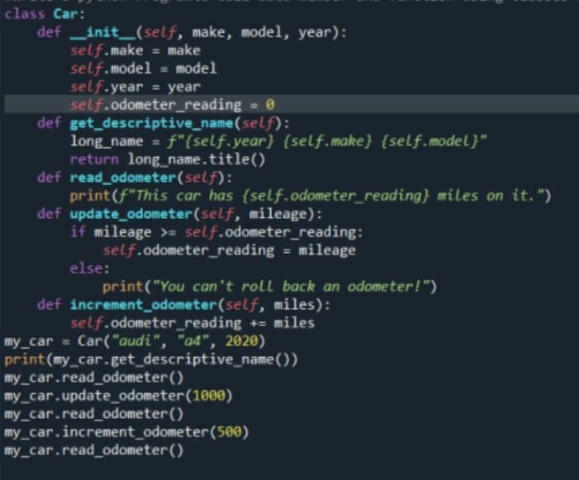
The results (Screenshot)
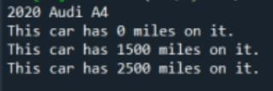

Lab Task No B(9(C))
:

Solution:
Brief description (3-5 lines)
Write a program to find sum of two numbers using class and methods
The code
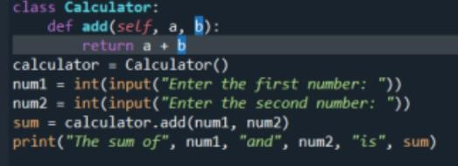
The results (Screenshot)
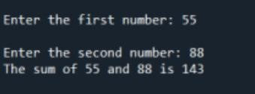

Lab Task No B(9(D)):

Solution:
Brief description (3-5 lines)
Write a program to read 3 subject marks and display pass or failed using class and object.
The code
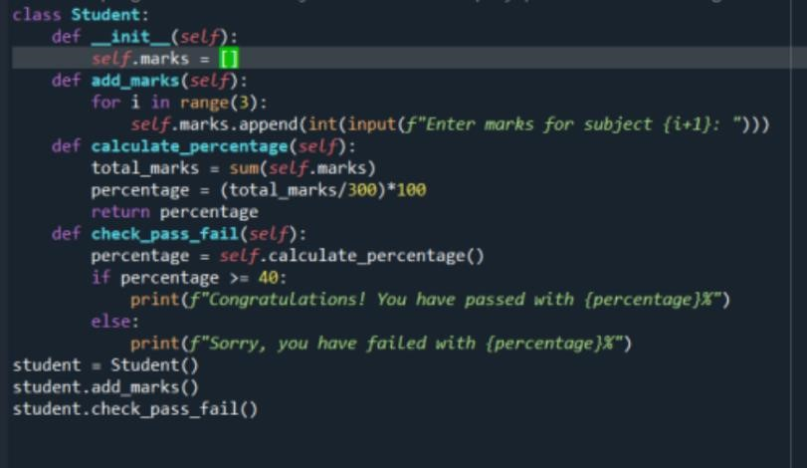
The results (Screenshot)
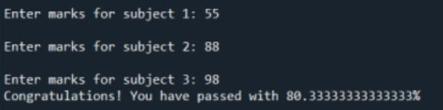

Lab Task No B(10(A)):

Solution:
Brief description (3-5 lines)
Using a numpy module create an array and check the following:
- Type of array
- Axes of array
- Shape of array
- Type of elements in array
The code
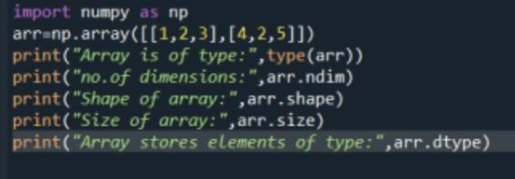
The results (Screenshot)
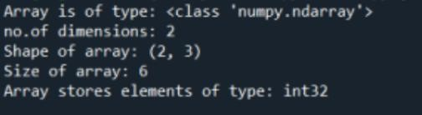

Lab Task No B(10(B)):

Solution:
Brief description (3-5 lines)
Using a numpy module create array and check the following:
- List with type float
- 3*4 array with all zeros
- From tuple
- Random values
The code
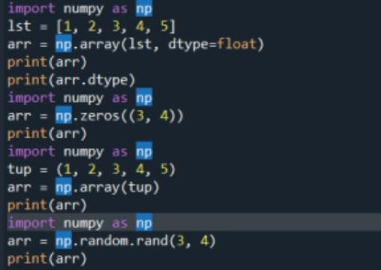
The results (Screenshot)
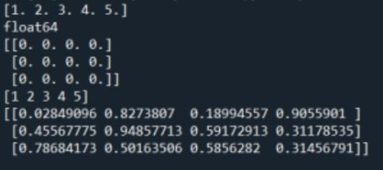

Lab Task No B(10(C)):

Solution:
Brief description (3-5 lines)
Using a numpy module create array and check the following:
- Reshape 3X4 array to 2X2X3 array
- Sequence of integers from 0 to 30 with steps of 5 3. Flatten array

4. Constant value array of complex type
The code
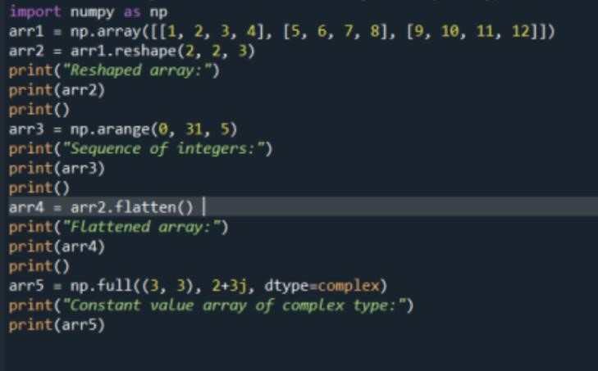
The results (Screenshot)
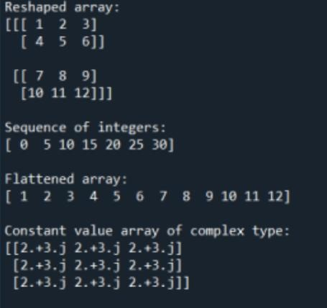

Lab Task No
B(
11(A))
:

Solution:
Brief description (3-5 lines)
Write a python program to concatenate the data frames with two different objects.
The code
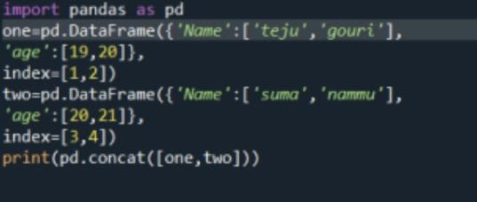
The results (Screenshot)
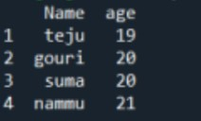

Lab Task No B(11(B))
:

Solution:
Brief description (3-5 lines)
Write a python code to read a csv file using pandas module and print the first and last five lines of a file.
The code
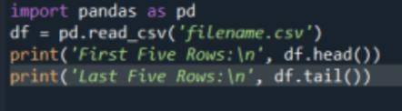
The results (Screenshot)
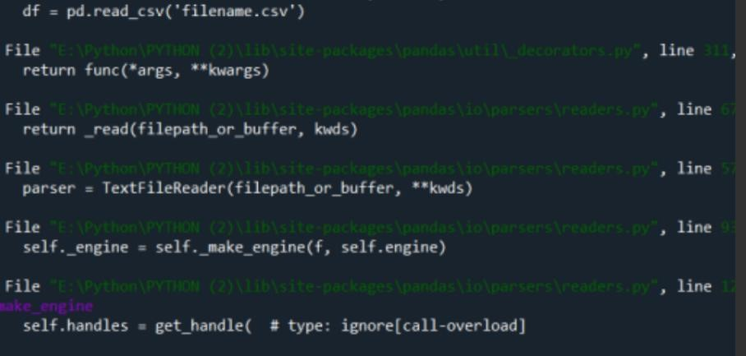

Lab Task No B(12(A)):

Solution:
Brief description (3-5 lines)
Write a python code to set background color and pic and draw a circle using turtle module.
The code
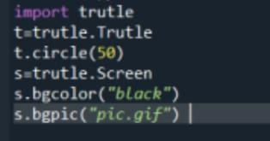
The results (Screenshot)


Lab Task No B(12(B)):

Solution:
Brief description (3-5 lines)

Write a python code to set background color and pic and draw a square and fill the color using turtle module.
The code
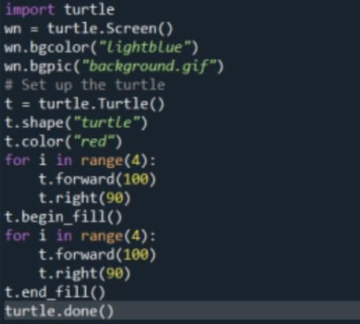
The results (Screenshot)
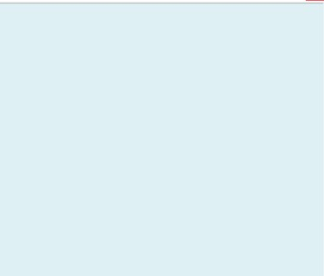
Lab Task No B(12(C)):

Solution:
Brief description (3-5 lines)
Write a python code to perform addition using functions with pdb module.
The code
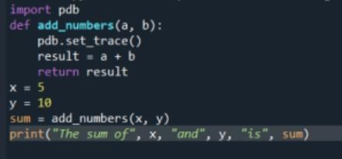
The results (Screenshot)
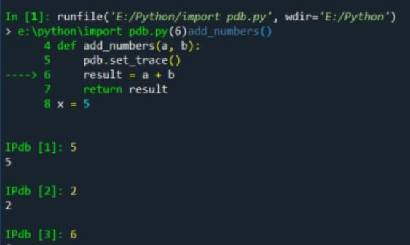
Conclusion
Setting up an environment and getting started with Python is a relatively straightforward process. With a little practice, you will soon be able to write programs that can solve real-world problems.

